Meshack Nyagwencha Bosire

Lab 04

4.1

4.2

1. What IP addresses did the virtual machines receive in the network?

172.22.222.180

B) How would be possible to change the IP address of the 1st machine for the IP address used in the previous exercise?

Ifconfig eth0 <new ip address>

4.3

1. What is the physical address of the 1st machine? The physical address is listed as Hwaddr which is 08:00:27:98:d2:19. How can you display this information (by using only a linux terminal)? By using the command ifconfig eth0

B) What is the name of the manufacturing company assigned to this physical address?

PCS Systemtechnik GmbH

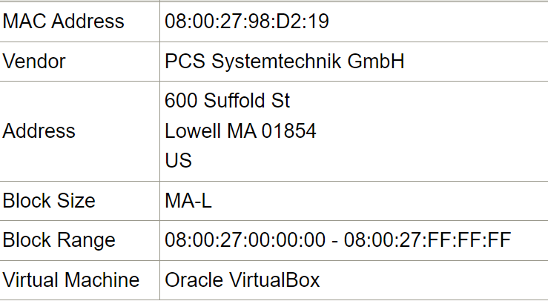

C) What does happen with the ARP table after shutting down the connection and after reconnection?

When a connection shuts down, the ARP entries associated with it are erased from the ARP table. The ARP procedure starts over upon reconnecting. To find out the MAC addresses of the IP addresses it wants to connect with, the system will issue ARP requests. It will add the updated mappings to the ARP table when it gets ARP replies.

D) Which command did you use precisely to insert a new entry to the arp table?

sudo arp -s <ip-address> <mac-address>

E) Which command did you use precisely to delete a static entry from the arp table?

sudo arp -d <ip-address>

4.4 A) Fill in the following table:

|  |  |  |  |
| --- | --- | --- | --- |
|  | | SOURCE | DESTINATION |
| (3) | IP | 128.119.199.43 | 128.119.248.227 |
| MAC | 6D-14-64-A8-8B-4D | 92-52-31-C4-F5-35 |
| (2) | IP | 128.119.199.43 | 128.119.248.227 |
| MAC | 6D-14-64-A8-8B-4D | 89-D9-AC-73-20-EF |
| (1) | IP | 128.119.199.43 | 128.119.248.227 |
| MAC | 6D-14-64-A8-8B-4D | 89-D9-AC-73-20-EF |

B) Explain what is the role of the physical address and that of the IP address in the network communication. Which type of address can be used in what cases (when)?